T and B cells
Both T and B cells are involved in the immune response and under the light microscope can not be distinguished. Surface markers are used to distinguish T and B cells.

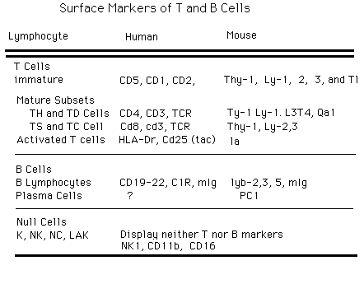

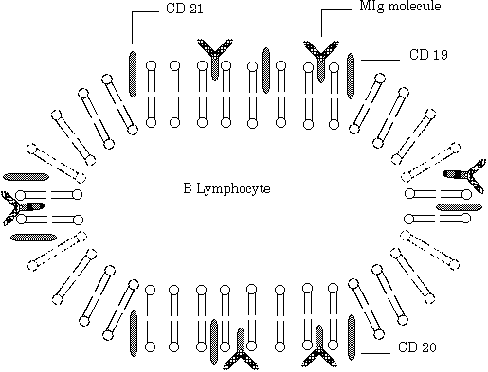

Return
This page is maintained by the Natural Toxins Research Center at Texas A&M University - Kingsville.

