Acquired Immune Deficiency Syndrome

Acquired Immune deficiency syndrome (AIDS) was first recognized as a disease in 1981 by the Center for Disease Control (CDC). AIDS leaves an individual vulnerable to illnesses that a healthy immune system would readily overcome. AIDS is acquired not inherited.
The current epidemic of AIDS is predominantly among the homosexual male and intravenous (IV) drug users in the United States and the heterosexuals in central African population. The incidence of AIDS is increasing among other groups male and female. Never has so much been learned about a disease and its causative agent in such a short time but we have not solved the problem.
In the early 1980 it was reported to CDC that young homosexual men had a diseases that caused pneumonia by Pneumocystis carinii, Kaposi's sarcoma, and various other oportunistic infections.
The causative agent of AIDS is a retrovirus known as human immunodeficiency virus (HIV) which are envelope viruses and posses an RNA genome. The retroviruses use reverse transcriptase to copy this genome in an infected host. There are two antigenic types of human immunodeficiency virus HIV1 and HIV2. There is also simian immunodeficiency viruses (SIV) which is antigenically related and found in Primates in Africa. These viruses are in the family lentivirus family.
Other information on AIDS
Animation of the HIV
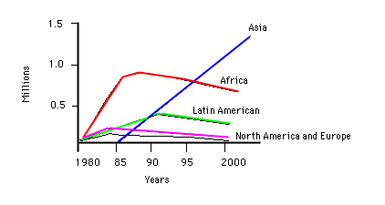
Estimated proportion of men and women infected with HIV
 | Men | Women
North America | 1 in 75 | 1 in 700
South America | 1 in 125 | 1 in 500
Western Europe | 1 in 200 | 1 in 1400
South Africa | 1 in 40 | 1 in 40

Possible causes of AIDS in the 1980

1. Sperm was known to be Immunosuppressive.
2. Antigen overload might be Immunosuppressive.
3. Amyl Nitrate is known to be Immunosuppressive.
4. Blood products (AIDS in hemophiliacs).
5. Retrovirus was discovered in AIDS Patients.

Retroviruses
The retroviruses can be divided into two groups:
Transforming viruses
The transforming retroviruses can cause cancer. This virus often carries an oncogene.
Bovine leukemia virus
Avian type C virus
Mammalian type C virus
Human T-cell lymphotrophic virus type 1 and 2 (HTLV1 and HTLV2) HTLV1 causes leukemia and does not have oncogene.
Cyotpathic Viruses
Visna virus
Caprine arthritis encepalitis virus
equine infectious animal virus
feline immunodeficiency virus
Immunodeficiency virus (HIV1, HIV2, SIV)
Both HIV1 and HIV2 are more closely related to SIV than they are to each other. HIV1 and HIV2 only have 40% DNA homology whereas HIV2 has 75% homology with SIV. There is also known cross species transfer of SIV.
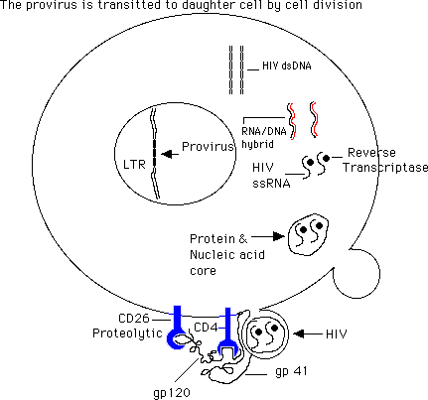
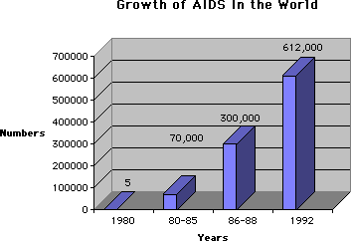
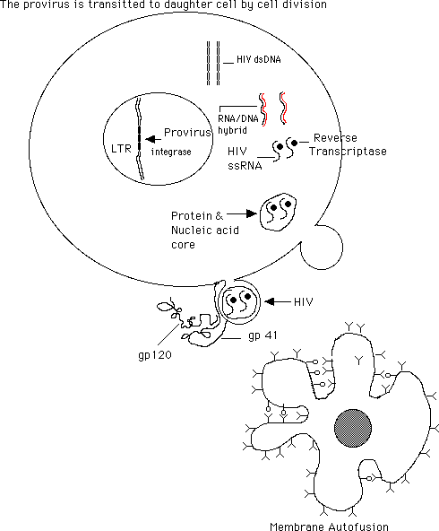
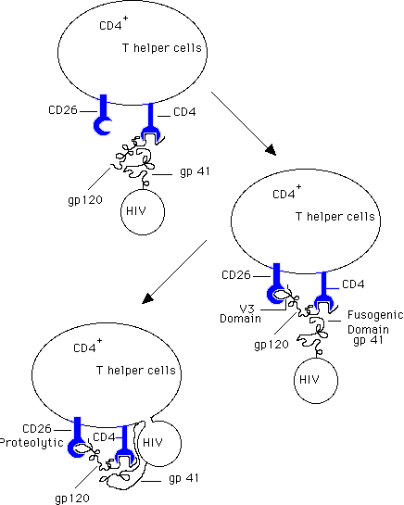
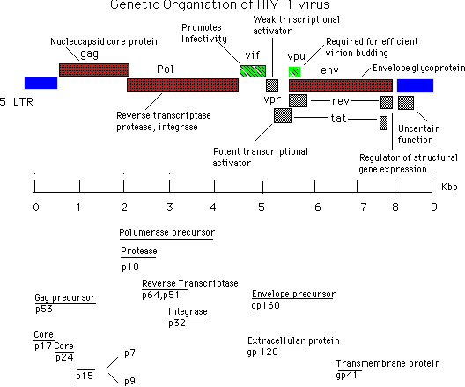

Return
This page is maintained by the Natural Toxins Research Center at Texas A&M University - Kingsville.

